**PART 01**

**PART 02**

**Question 01**

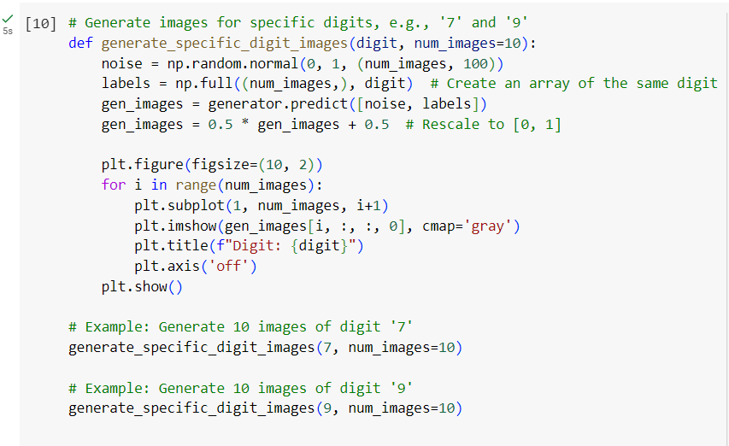

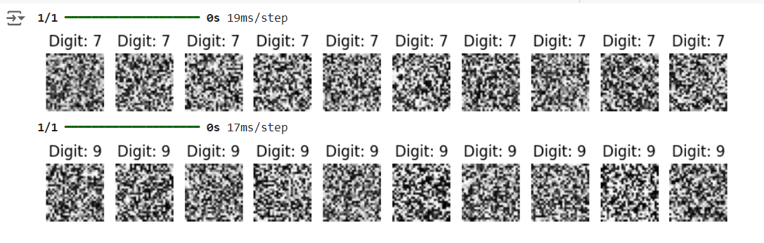

**Question 02**

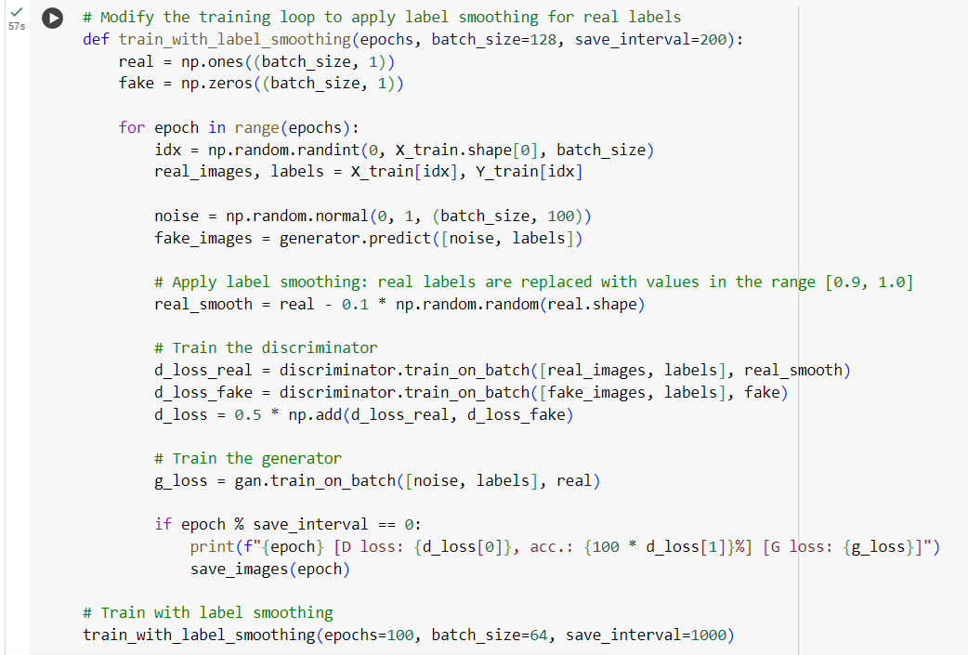

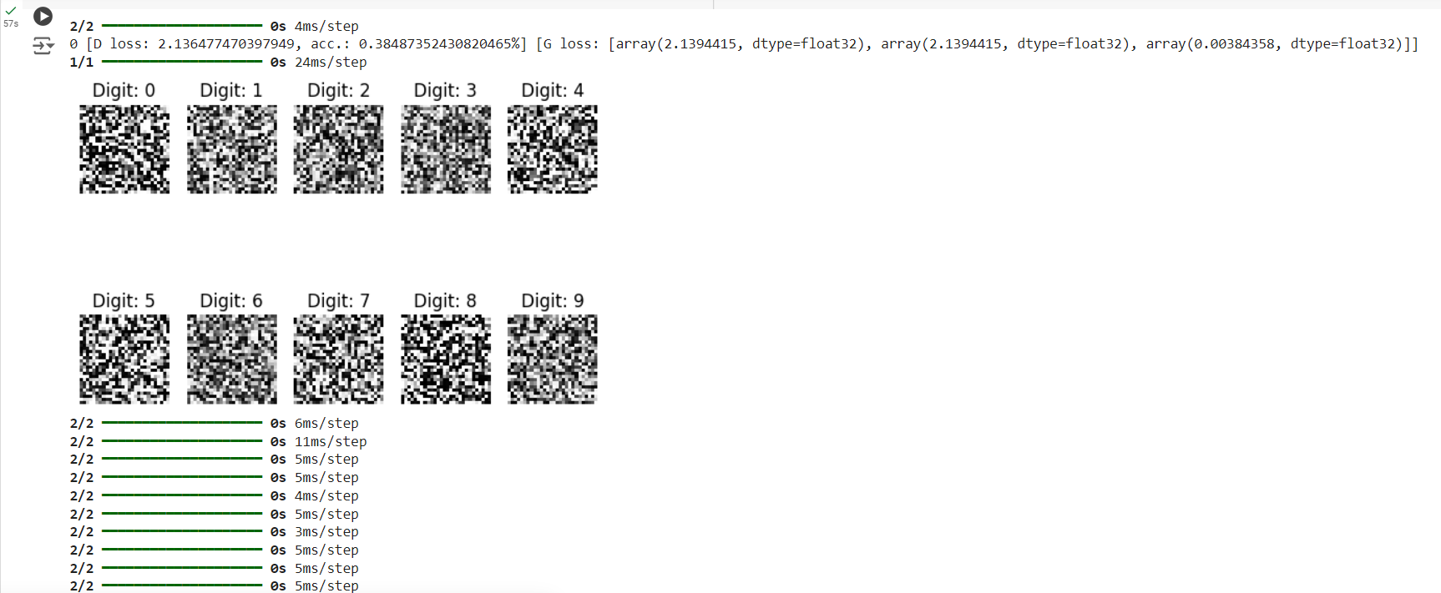

**Question 03**

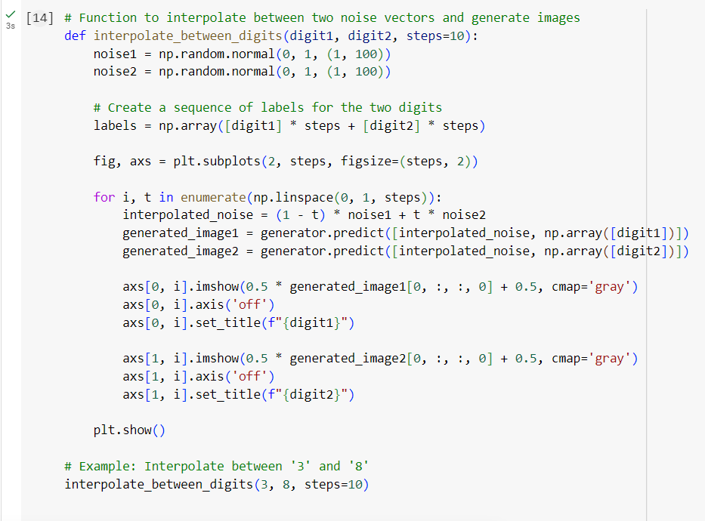

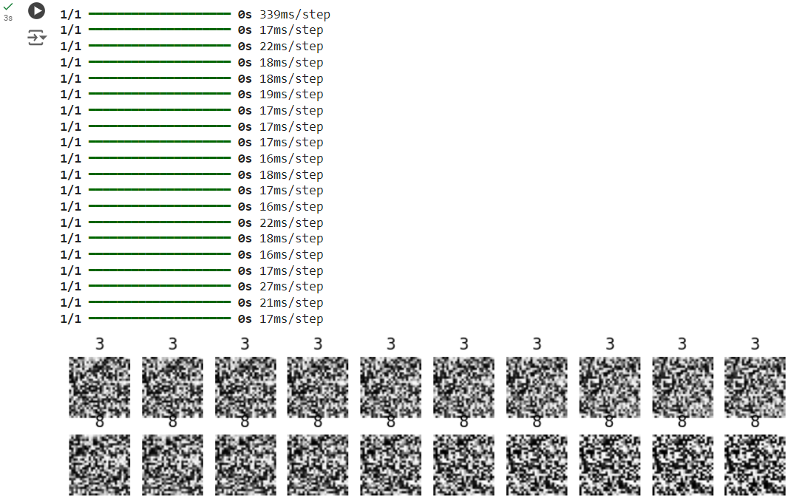

**PART 03**

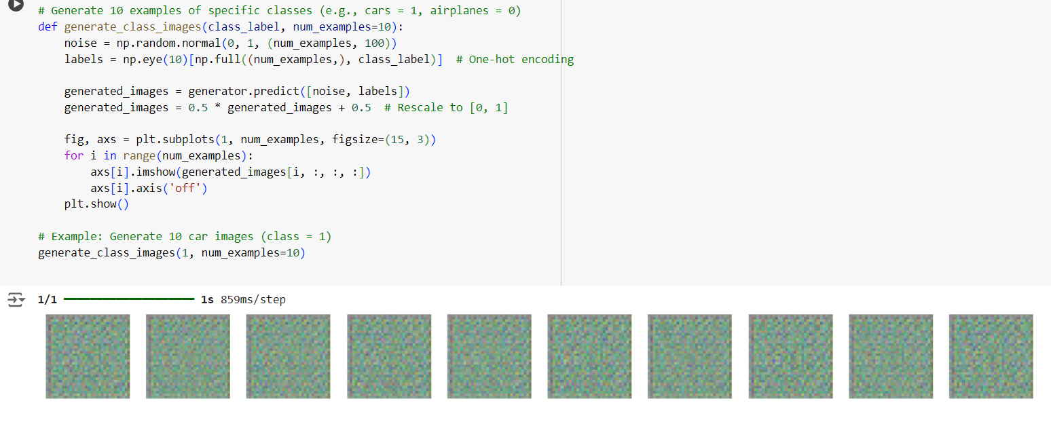**Question 1**

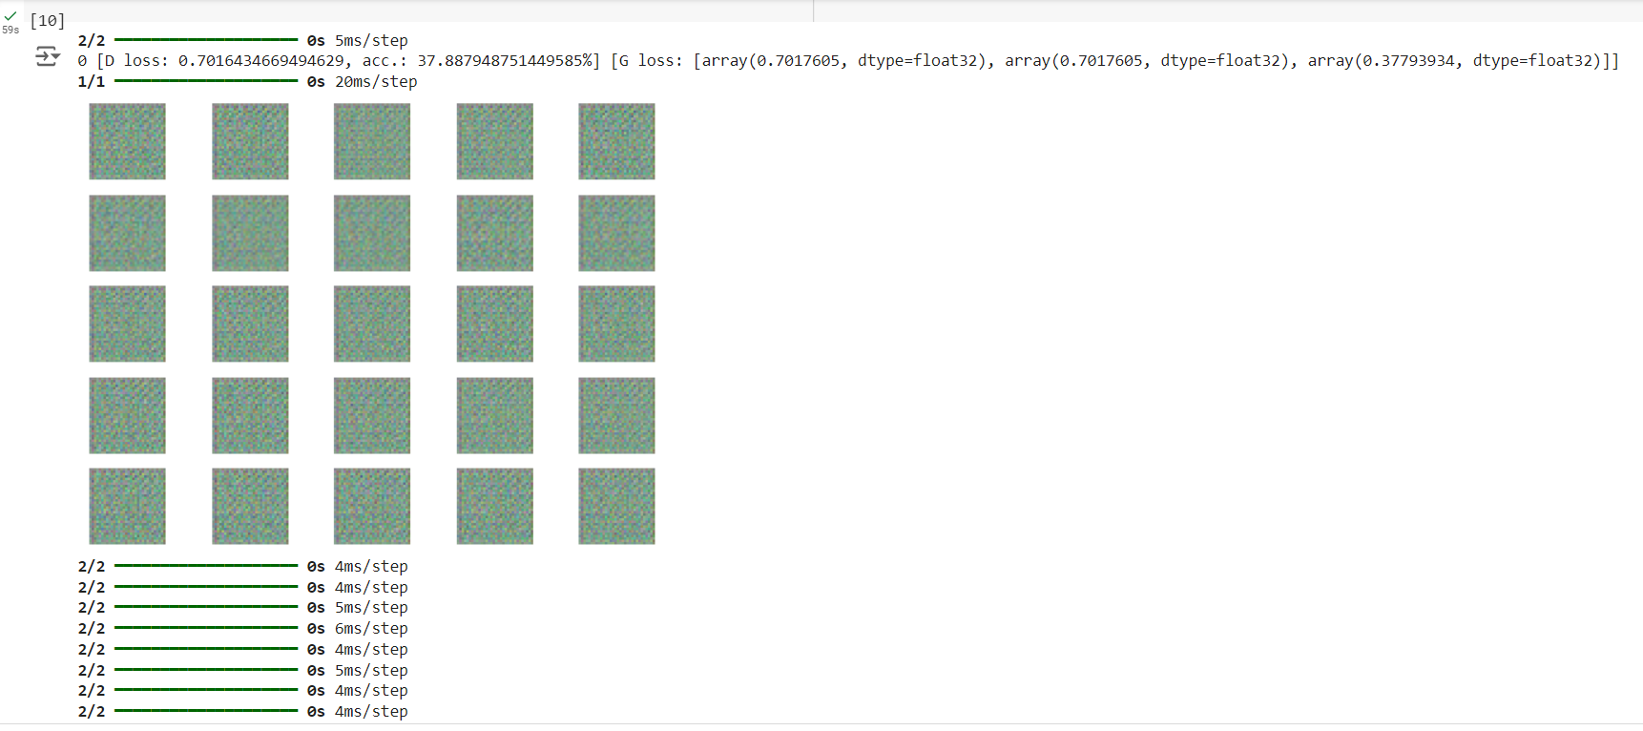**Question 2**

**Question 3**

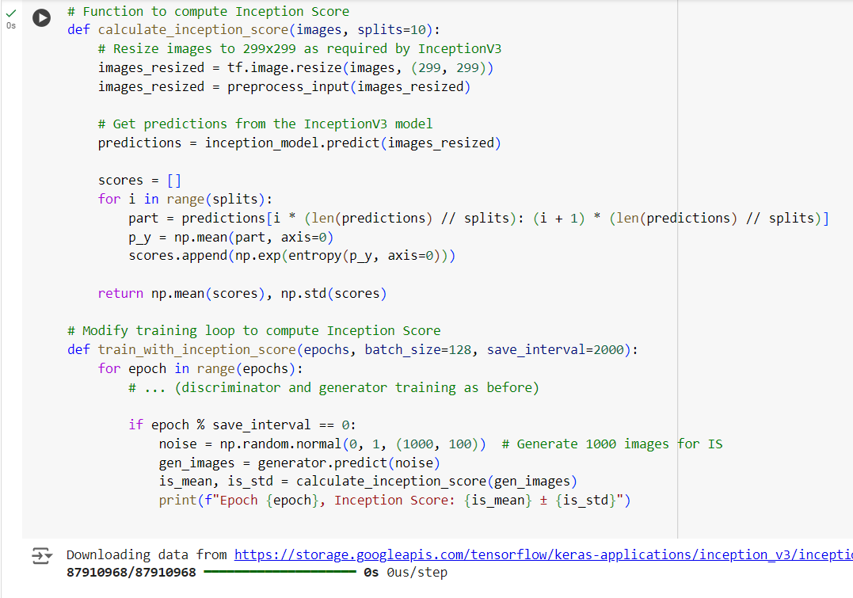

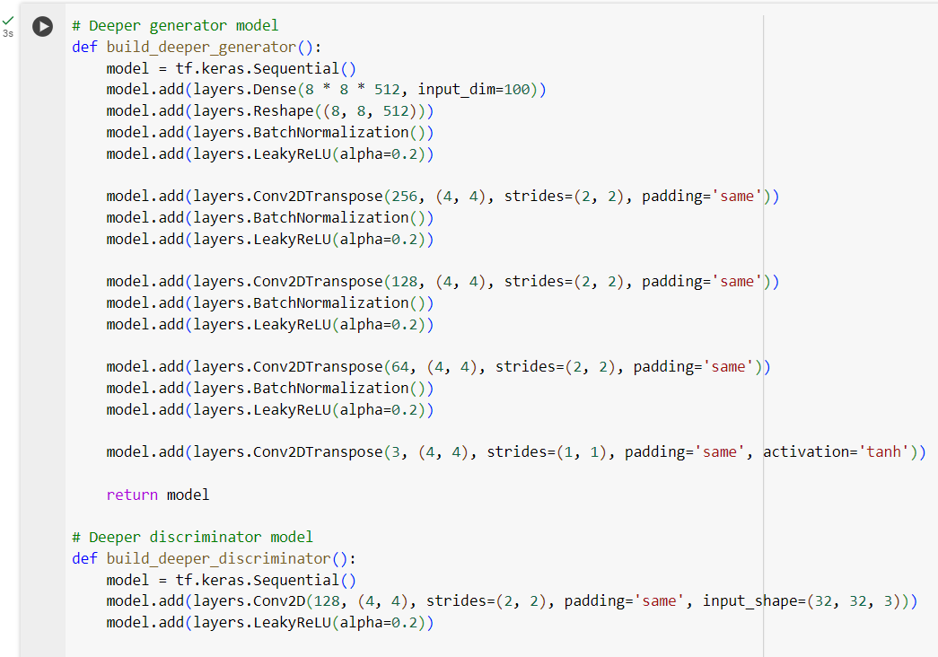**Question 4**

**b. Impact of Parameter Changes**

* **Latent Space Size**: Increasing the latent space size (e.g., from 100 to 200) allows the model to capture more complex features, often improving image diversity and detail. However, too large a space may cause difficulty in training, leading to noisy or less coherent images.
* **Optimizers**: Using optimizers like Adam with different learning rates (e.g., 0.0002) impacts training stability. A lower learning rate tends to produce more stable training and gradual improvements, while higher learning rates can lead to faster convergence but also instability.
* **Batch Size**: Smaller batch sizes (e.g., 32) can lead to noisy gradients and unstable training, but might help the model learn more varied features. Larger batch sizes (e.g., 128) result in smoother learning, but can overfit or require more computational resources.

**c. Quality and Range of Generated Images**

* **Quality**: Over time, generated images become sharper and more detailed, especially when the GAN is well-tuned. Earlier epochs often produce blurry images, while later ones can produce more realistic images. However, overly complex models or unstable training can result in mode collapse, where the generator outputs very similar images.
* **Range**: The range of generated images depends on the diversity of the latent space. With proper tuning, the model generates a wide variety of objects and styles within a class. A smaller latent space or poorly tuned parameters might result in less diverse outputs, where the generated images look repetitive.